Question1:

c

c-c

c-c-c

c-c-c-c

Question2:

(1).

Rank($u_{0}$) = 1 / 3

Rank($u_{1}$) = 2 / 4

Rank($u_{2}$) = 1 / 4

Rank($u_{3}$) = 2 / 2

Rank($u_{4}$) = 2 / 2

Rank($u_{5}$) = 1 / 2

Rank($u_{6}$) = 2 / 1

Rank($u_{7}$) = 3 / 1

Rank($u_{8}$) = 3 / 1

Merging the same vertices

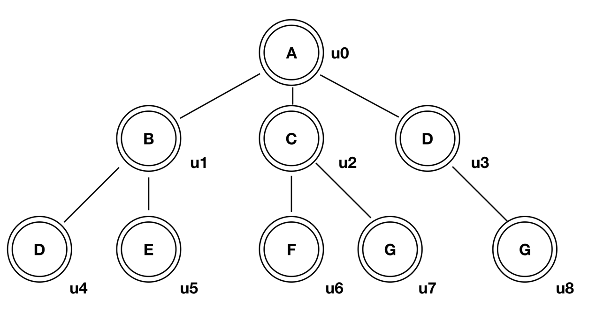

(2).

Core: $u_{0}$, $u_{1}$, $u_{2}$. $u_{4}$, $u_{5}$

Forest: $u_{3}$

Leaf: $u_{6}$, $u_{7}$, $u_{8}$

Question:

I choose seed is $v_{3}$.

w($v_{3}$) = 1, w($v_{2}$) = 0.4, w($v_{7}$) = 0.3, w($v_{9}$) = 0.5, w($v_{0}$) = 0.12,

w($v_{6}$) = 0.08, w($v_{1}$) = 0.06, w($v_{4}$) = 0.3, w($v_{8}$) = 0.05, w($v_{5}$) = 0.024

the maximum sum is 2.824